**Developed and Prepared By:** Ajunumasa Sadanandan

**Development Man-days:** 10

**Document Submission Date:** 30-11-2020

**Git Hub Link :** <https://github.com/ajunu/AjunuPhase2/tree/master/Simplilearn_Phase2Project>

**Project Details**

**Project Name**: Student Admin Portal

**Project Description:** Design and develop a backend administrative portal for the Learner’s Academy. Use the GitHub repository to manage the project artifacts.

**Language:** Java EE, Maven project

**Methodology:** Agile Scrum Methodology

**Sprint required**: 2

**Story Points** = 12

**Software’s Used:** Eclipse - Project Development, Tomcat 9.0, PhpMyadmin

**Java Concepts Used:** Classes, Interfaces, java nio, Exception Handling, Scanner, Sorting techniques, Hibernate, Json-lib, MysqlConnectorJ, Log4J, Datatables, javaScript, Chart.js

**Project Description in Detail**

Learner’s Academy is a school that has an online management system. The system keeps track of its classes, subjects, students, and teachers. It has a back-office application with a single administrator login..

**The administrator can:**

● Set up a master list of all the subjects for all the classes  
● Set up a master list of all the teachers  
● Set up a master list of all the classes  
● Assign classes for subjects from the master list  
● Assign teachers to a class for a subject (A teacher can be assigned to different classes for different subjects)  
● Get a master list of students (Each student must be assigned to a single class)

**Solution Overview**

**Below is the welcome page of the application**

<http://localhost:5051/school_admin_panel/>

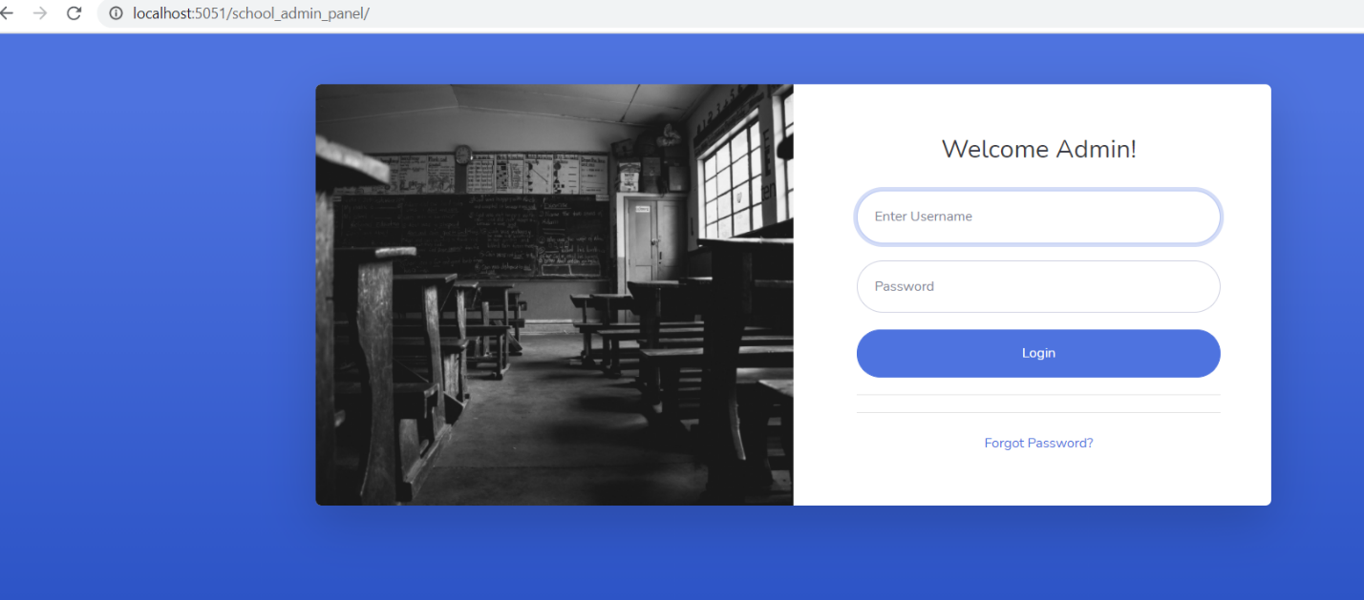

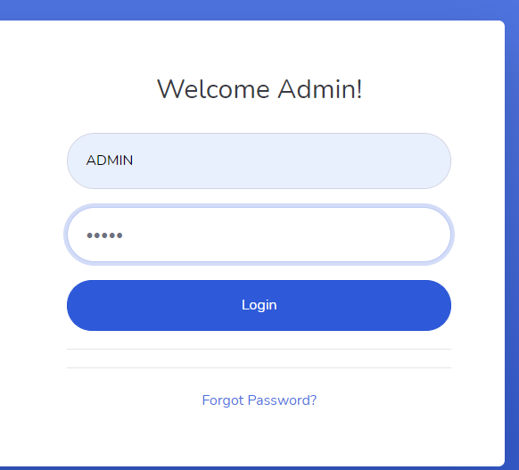

Admin username and password as admin will give a authentication success message when login.

**Add Classes as below**

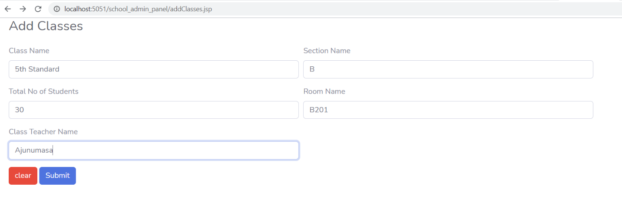

**Add Subjects as below**

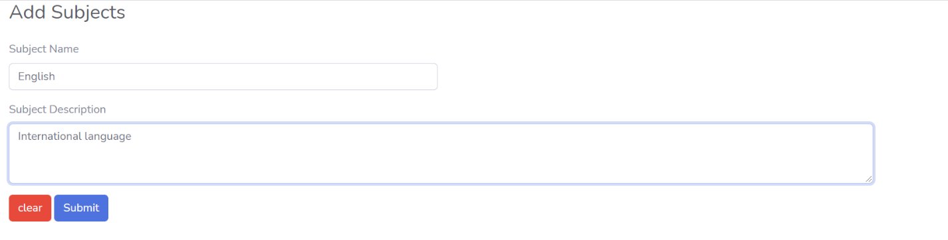

**Add Teachers as below**

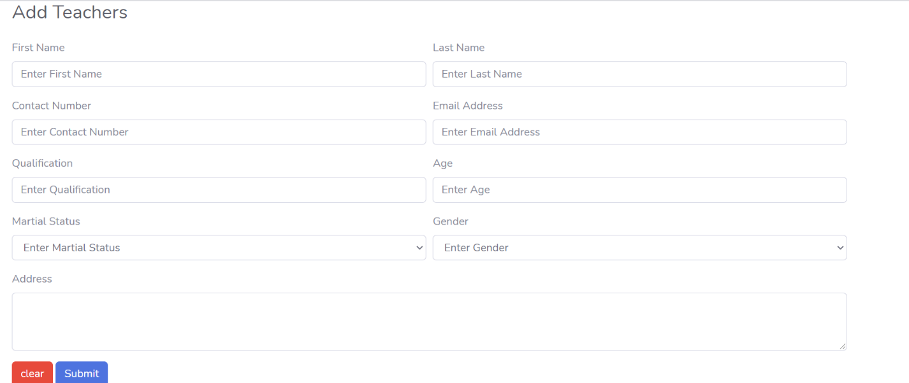

**Map the subjects with the classes goes here:**

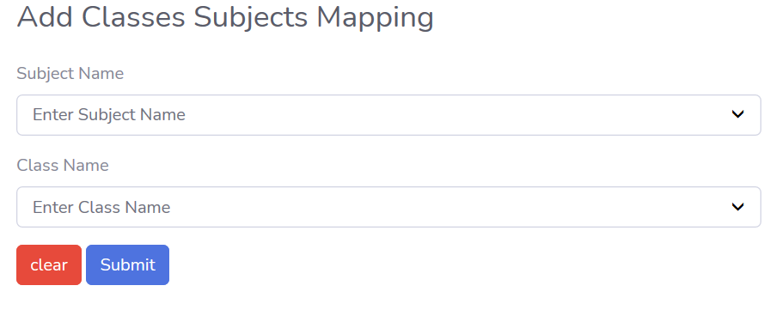

**Mapping the Teacher with the respective classes and subjects goes here:**

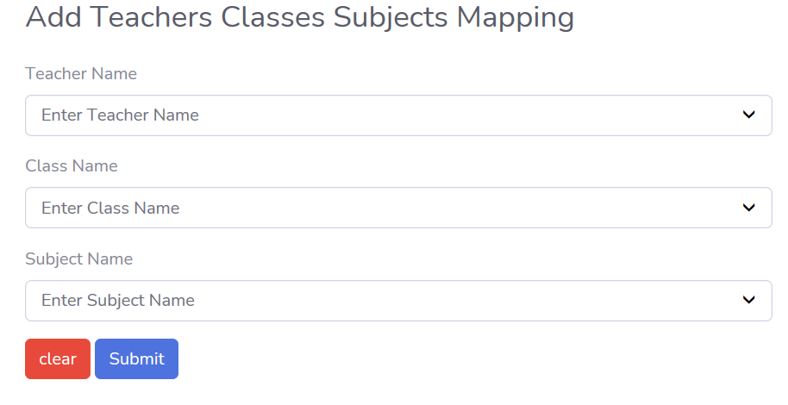

**All the available classes with the total no of students will list goes here**

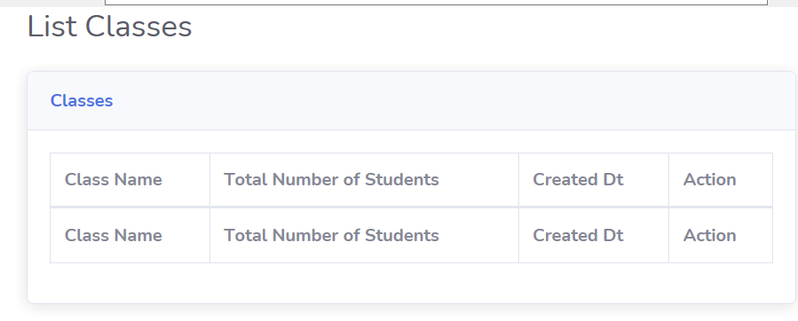

**List down all the subjects available**

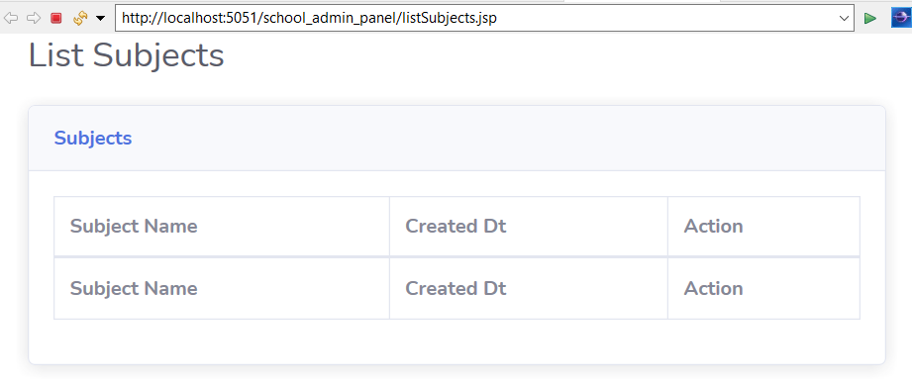

**List down all the Classes and Subjects mapping**

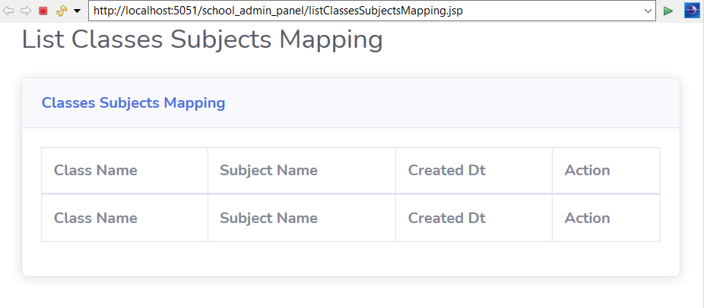

**List Teachers availability and their details like phone now and qualification, gender**

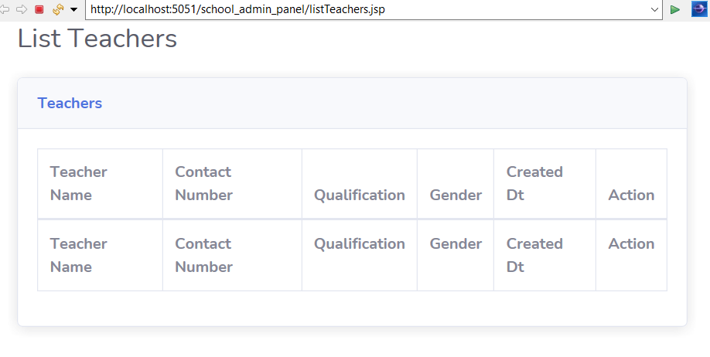

**Here we can map the Teachers with Respective class and Subjects**

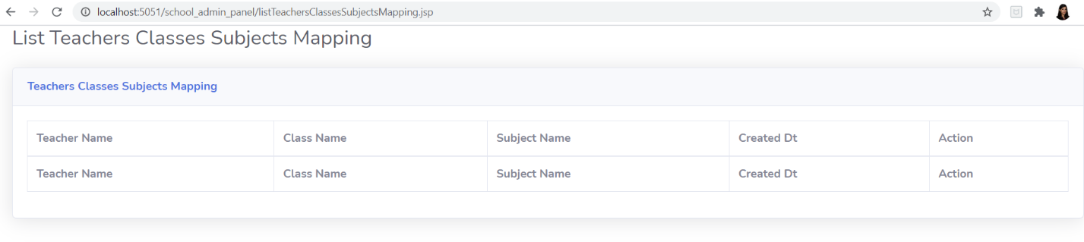

**We can Edit the classes as below**

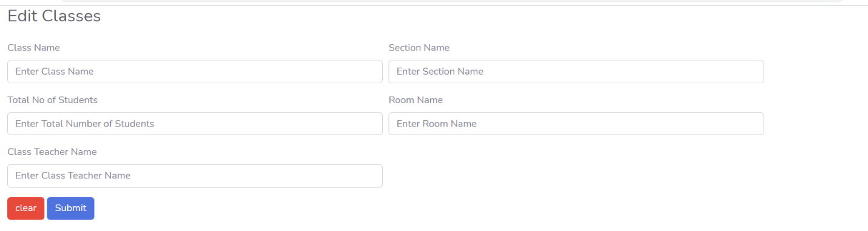

**We can edit the subjects as below**

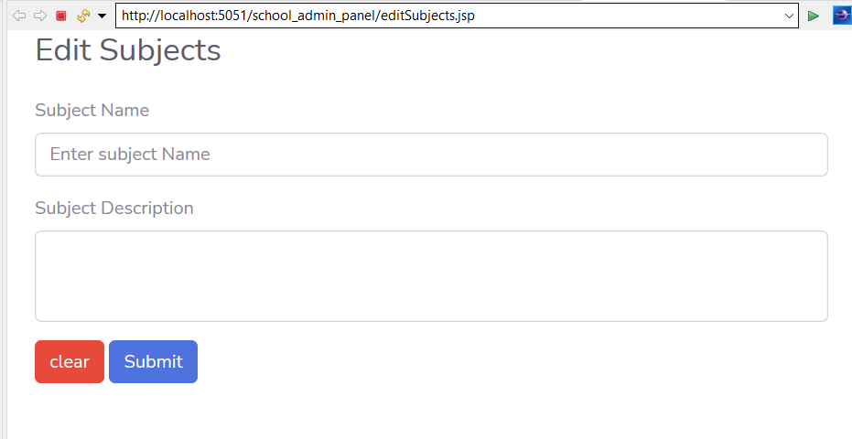

**We can edit the Teachers details as below**

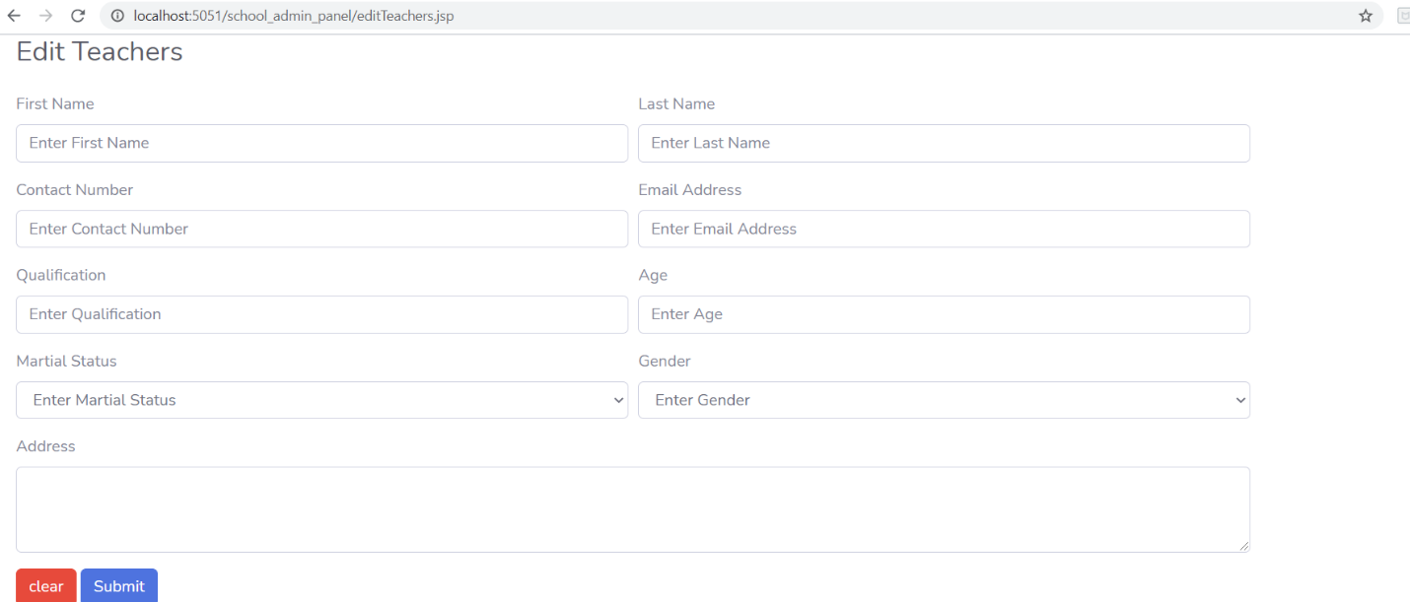

**=====================================================================**

**Database** :- phpMyAdmin

**In order to store the data , the master database is schooladmin**

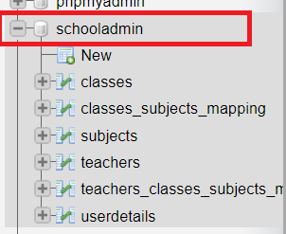

There are 6 tables created to store the data.

1. classes : - all the available details goes here.
2. Classes_subjects_mapping :- Mapping of each subjects and respective class goes here
3. Subjects:- all the subject details go here.
4. Teachers – all the teachers data go here
5. Teachers_classes_subject_mapping – Mapping of respective teachers for the subjects and class goes here
6. Userdetails – all the user login details goes here

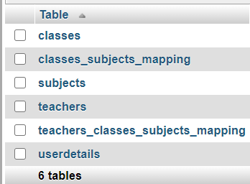

**The Backend (DATABASE) - PHPMyadmin**

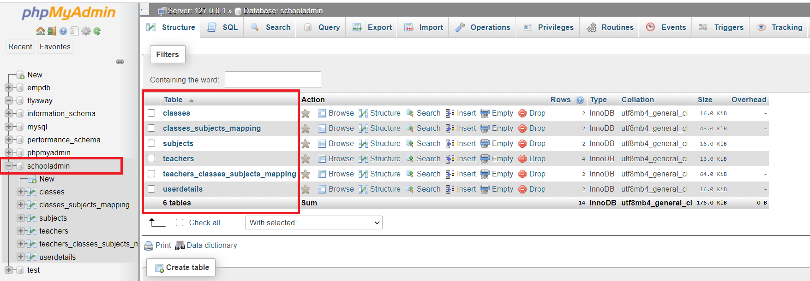

**Flow chart**

**3.1 The objective of this session if to show how the user interacts with the flow of the**

***Company Lockers Pvt. Ltd.***

Start

Login and user authentication based on Admin and User based login

Add Classes, Subjects, Teachers and Map subjects with classes and then with teachers

**­­­**

NO

Invalid User

IF

Valid Admin

Welcome Page

YES

Edit subjects, classes, teachers and map each other

Confirmed

**END**

|  |
| --- |
| **USER STORY POINTS** |
| |  | | --- | | Create Maven project with all the required dependencies for Developing a backend administrative portal for the Learner’s Academy – 1 | | Analyse Requirements Of Learner’s Academy -2 | | Create all the JSP file required -1 | | Create all the servlets inside the respective package -1  Create the servlets and classes for Add classes, add subjects and Add teachers-1  Create servlets and JSP for Mapping classes and subjects and then with the teachers-1  Create servlets and JSP for edit classes, edit teachers and edit subjects-1 | | Create the database for Student admin details in PhypMyAdmin-2 | | Create Hibernate dependency and link the database-1 | | Unit Testing for all classes, subjects, teachers, mapping and editing -1 | | Environment Setup, Daily Stand Up, Retrospective Meetings, Sprint Demo-1 | |

**6. Github link**

**This section lists where the source code is located and from where the user can download and use it.**

<https://github.com/ajunu/AjunuPhase2/tree/master/Simplilearn_Phase2Project>